## 指针类型赋值兼容性检查

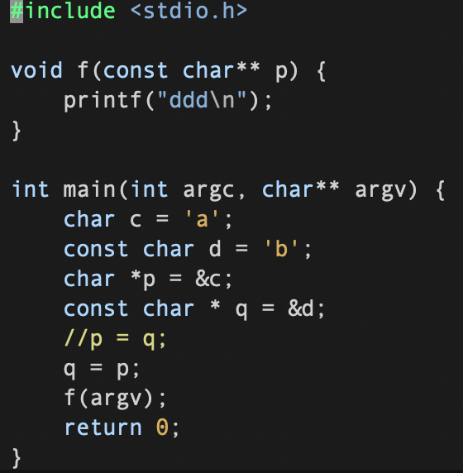

赋值操作的约束条件(对于指针)

1. *两个操作数都是指向有限定符或无限定符的相容类型的指针,*
2. *左边指针所指向的类型必须具有右边指针所指向类型的全部限定符.*

q=p

q是指向const char的指针

p是指向char的指针

q和p本身没有限定符,满足1;

q指向的类型包含p指向类型的限定符(无),q指向的类型的限定符为const,满足2

所以赋值合法;

p=q

1满足但是2不满足,类型不兼容,无法赋值.

p=argv

p是指向const char*的指针

argv是指向char*的指针

p和argv指向的类型都没有限定符, 满足2;

p和argv本身没有限定符但是他们指向的类型是不相容的, const char* 和char*不是相容的类型

## 算术转换

算术转换:

操作数数为算术类型的双目运算符的两个操作数中:

有long double,转long double

有double,转double

有float,转float

均为整型进行如下整型升级:

-char short int 或者int型位段(bit-field), unsigned or signed, enum

如果能用int完整表示(int 为32位),那么上述源类型自动转换为int,否则转换位unsigned int

-有unsigned long int,转unsigned long int

-无unsigned long int,有一个是long int

-另一个是unsigned int, 如果能用long int完整表示unsigned int,转为long int,否则转化为unsigned long int

-另一个不是unsigned int,转化为long int

-无unsigned long int, 无long int,有一个是unsigned int,转化为unsigned int

-两个都为int,不需要整型升级

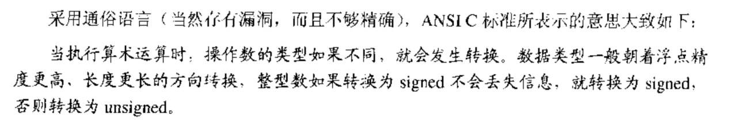

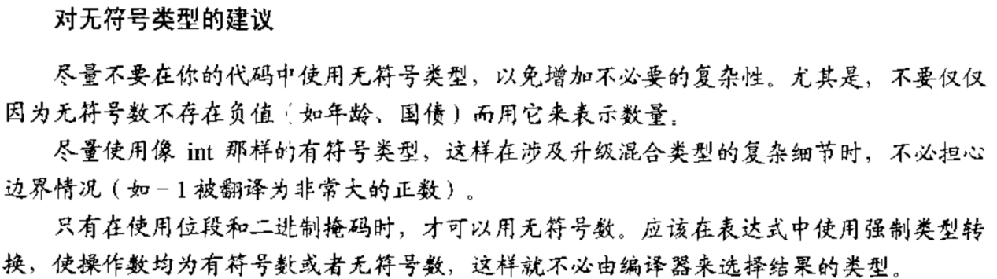

## 语言缺陷

##### 多做之过

C函数可见性默认为全局可见:一个符号要么全局可见,要么对其他文件都不可见;

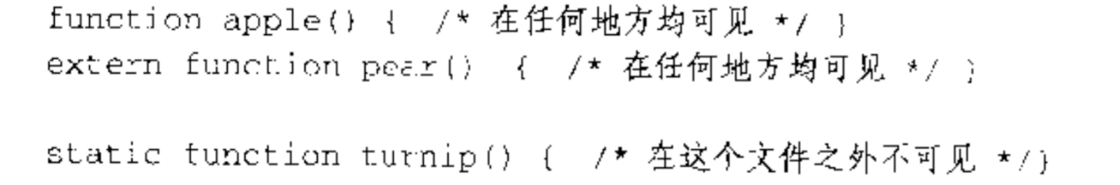

容易引起interpositioning,即用户编写的同名函数取代了系统的库函数

##### 误做之过

**操作符可能产生歧义:**

Sizeof(int) // 针对类型名,需要括号

Sizeof a // 针对变量,不需要

Sizeof *p //不需要

**运算符的优先级问题:**

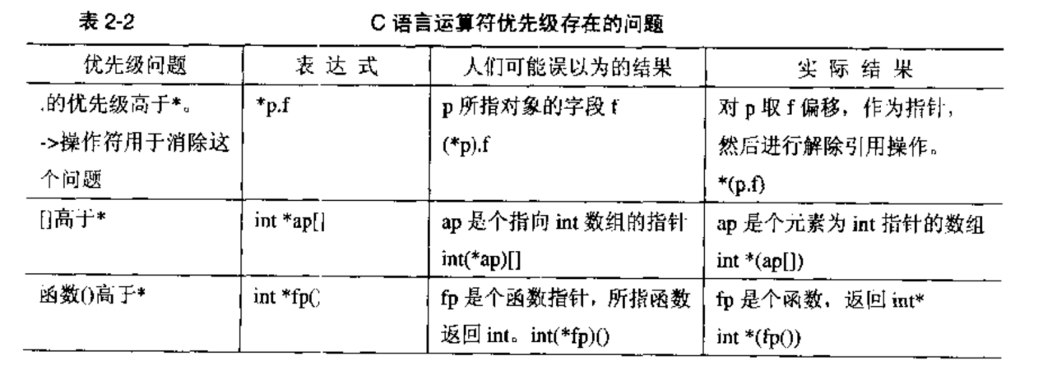

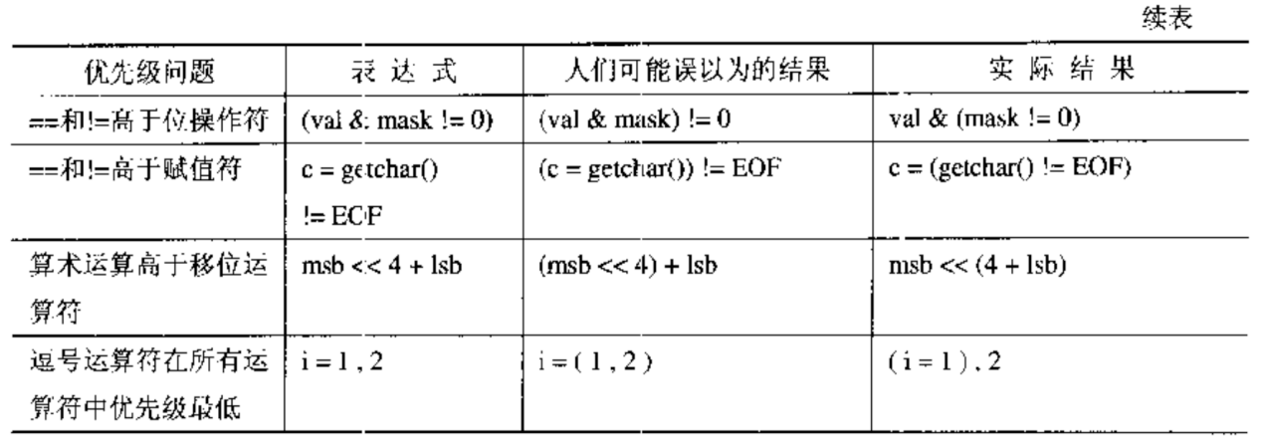

**操作数的计算顺序:**

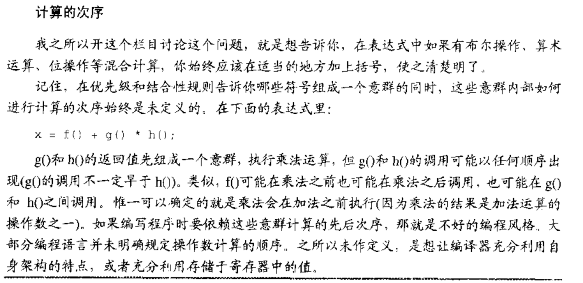

另外,函数调用中,各个参数的计算顺序也是不确定的;

&& 和 ||计算顺序严格从左到右,短路求值;

**操作符的结合性:**

操作符的结合性在表达式中出现两个以上相同优先级的操作符的时候发挥作用:

赋值操作符(包括复合赋值操作符)具有右结合性,从右往左执行操作;

位操作符具有左结合性,从左到右执行操作;

##### 少做之过

Lint被从编译器中分离出来了

## c语言的声明

##### 声明器(declarator)

就是标识符以及与它组合在一起的任何指针、函数括号、数组下表等,如下表所示(包含了初始化内容):

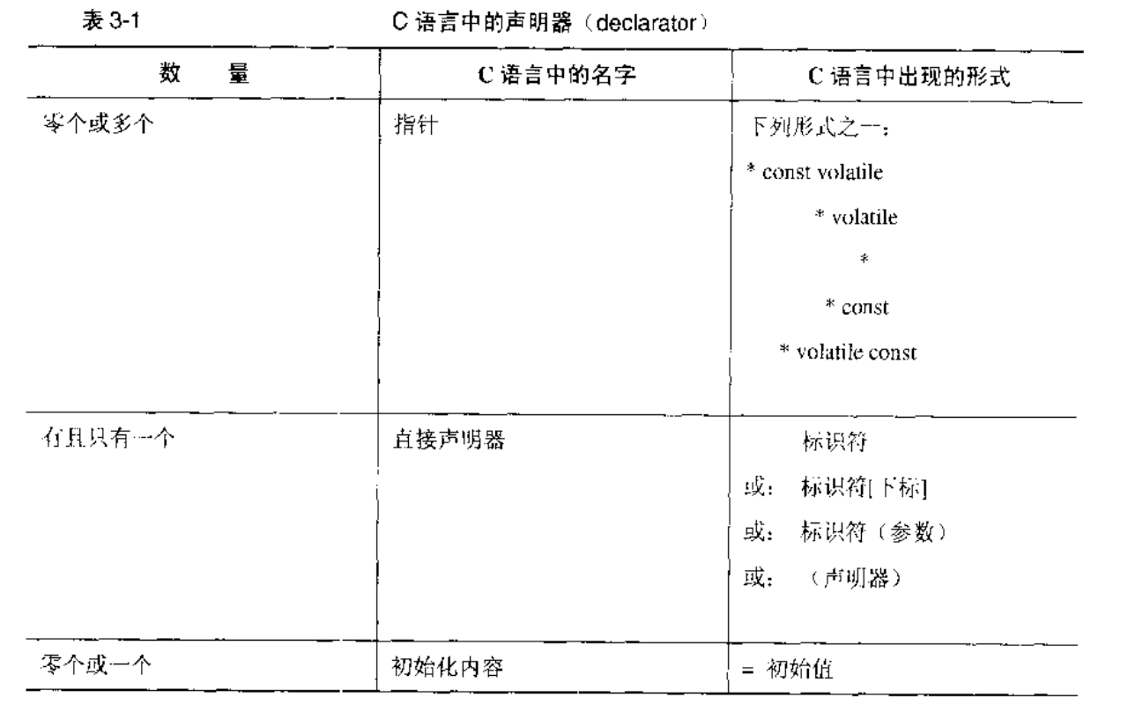

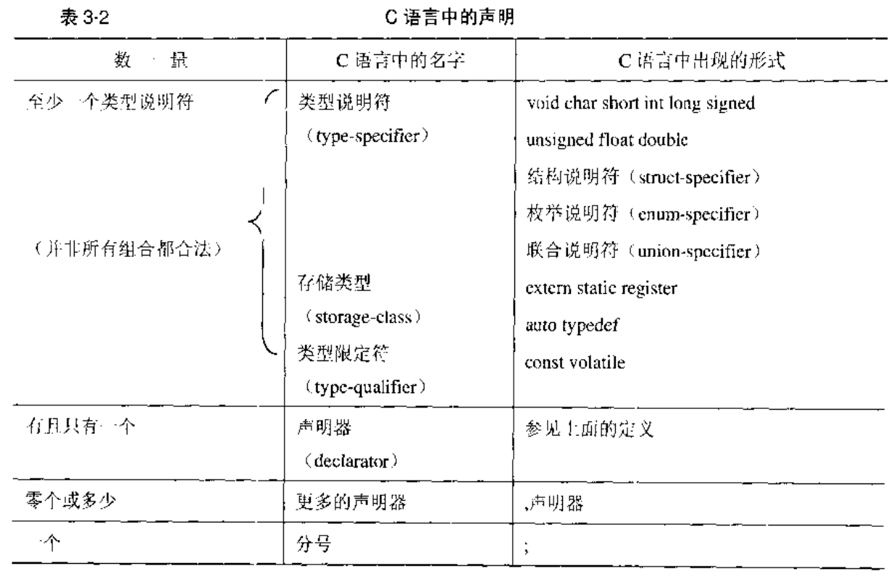

声明:

函数的返回值不能是函数,但是允许是一个函数指针;

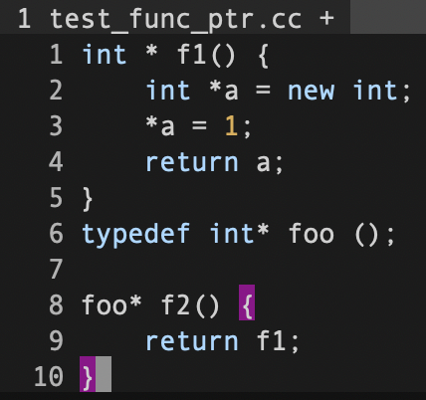

函数的返回值不能是一个数组,但是允许是一个指向数组的指针;

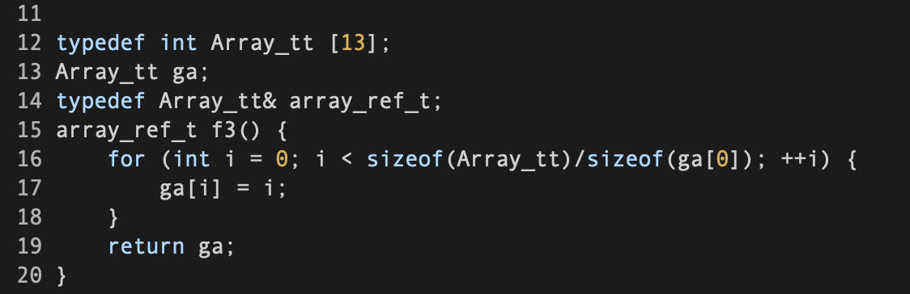

数组里面不能有函数,但是允许有函数指针; ([]比*优先级更高)

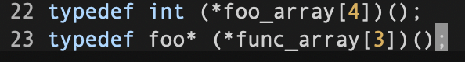

数组里面允许有其他数组;

##### 结构和联合

union的用法:

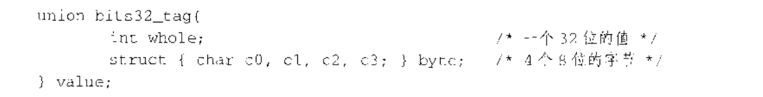

##### 声明中的优先级规则

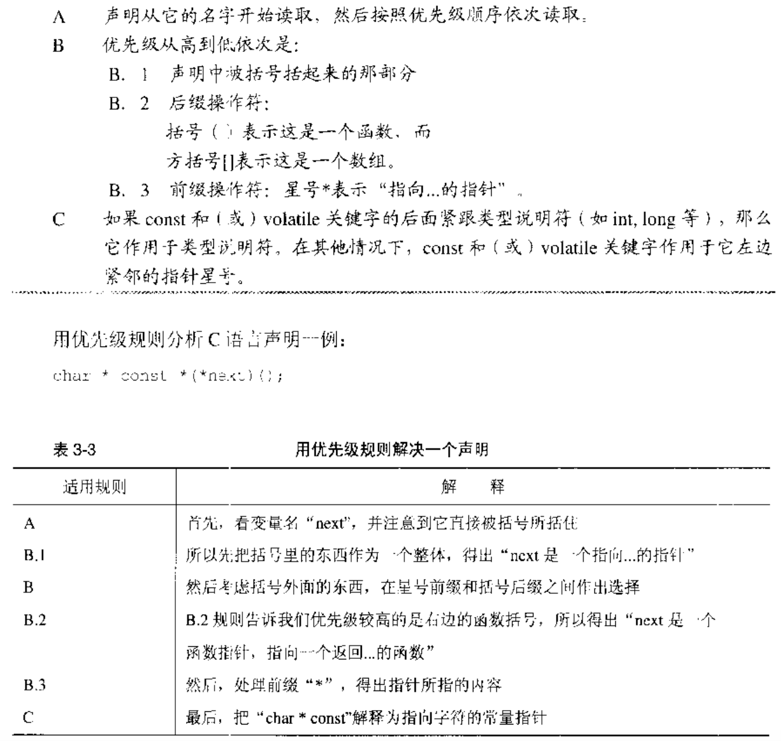

next是一个指针,它指向一个函数,该函数返回一个指针,该指针指向一个char类型的常量指针.

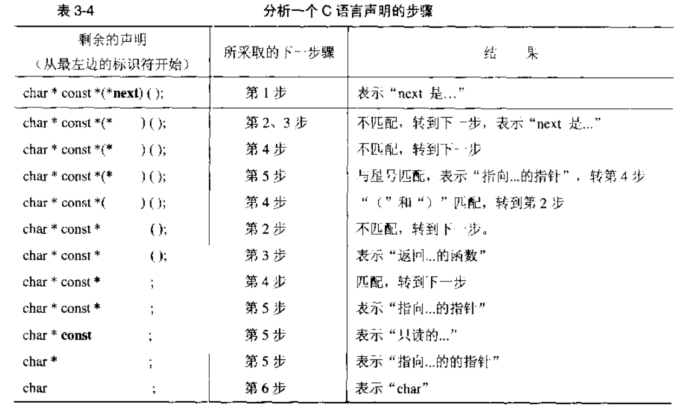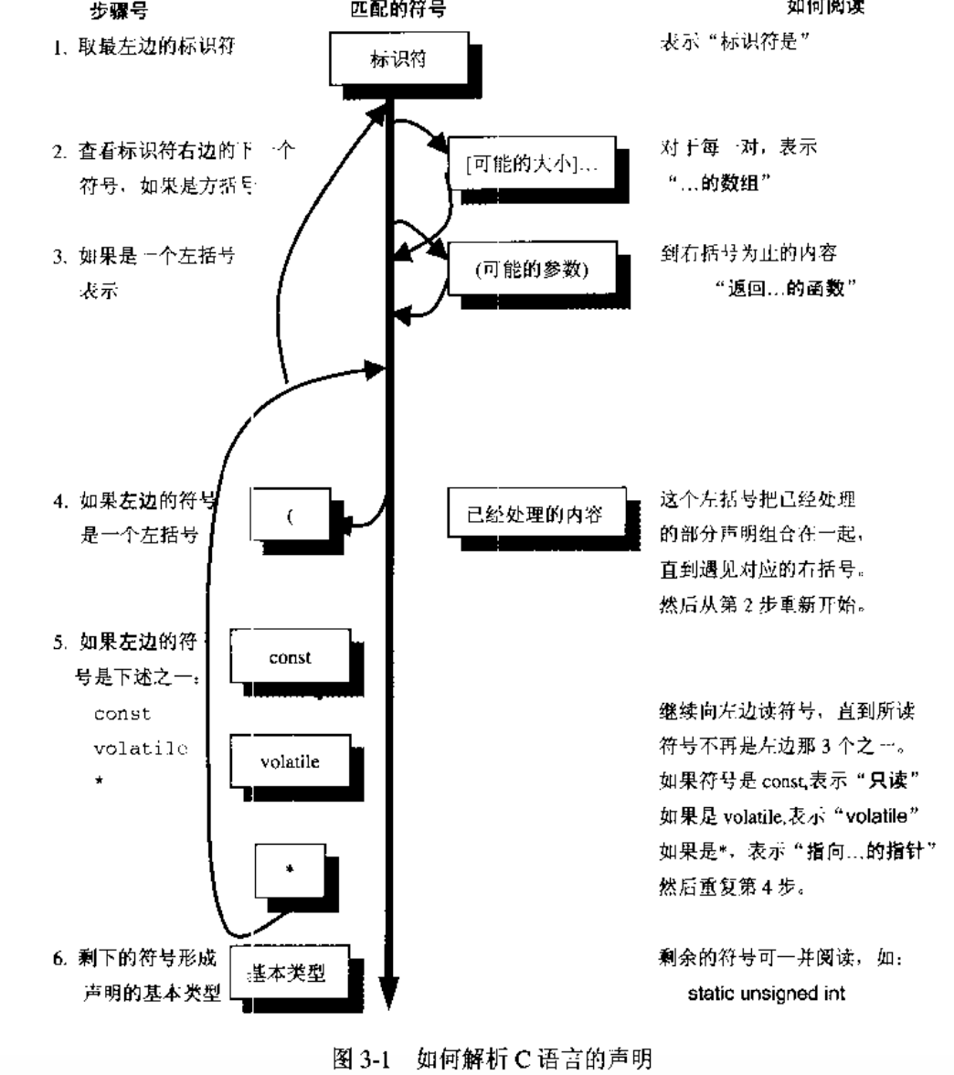

char *(* c[10])(int **p);

c是一个数组,数组中有10个元素,每个元素是一个指针,每个指针指向一个函数,函数的参数为一个指向int型指针的指针,函数的返回值为指向char的指针.

##### typedef

普通的声明:这个名字是一个指定类型的变量;

typedef声明:这个名字是指定类型的同义词;

void (*signal(int sig, void(*func)(int)))(int);

void (*signal( ))(int);

signal是一个函数(没有括号先check后面的操作符), 该函数的参数为(整型int, 返回void 以int为参数的函数指针),该函数返回一个如下的函数指针,指向一个返回void以int为参数的函数

void (*)(int)

用typedef简化signal的类型声明:

typedef void(*ptr_to_func)(int);

ptr_to_func signal(int, ptr_to_func);

###### typedef定义的类型别名不能进行类型扩展

typedef int my_int;

unsigned my_int i; // error

###### 注意typedef struct和struct的区别

typedef struct fruit_tag {int weight, price_per_lib;} fruit_type;

fruit_tag是结构标签要和struct一起使用,fruit_type是结构类型,最好使用结构标签的形式使用结构,这样更清晰.

typedef应该用在

数组、结构、指针以及函数的组合类型

可移植类型的声明,比如你需要一种至少20bit的类型时,可以对它进行typedef操作,这样移植代码到其他平台只需要修改typedef处的声明

简化强制类型转换时需要的类型名字

## 数组和指针

##### 声明和定义

声明:可以多次出现,描述对象的类型,用于只带其他地方定义的对象

int my_array[100];

定义:只能出现一次,确定对象的类型并分配内存,用于创建新的对象

extern int my_array[];

extern int my_array[100];

##### 左值与右值

左值表示地址,存储结果的地方,编译时可知;//数组名属于不可修改的左值;

右值表示地址中的内容,运行时才知;

##### 编译器对数组和指针处理的不同

这里关键地方在于,每个符号的地址在编译时可知,所以编译器对这类符号可以指直接进行操作,不需要增加指令首先取得具体的地址.相反,对于指针,必须首先在运行时取得它的当前值,然后才能对它进行解除引用操作:

char a[9] = “abcdefgh”;

char c = a[i];

编译器符号表具有一个地址(a) 9980

运行时步骤1:取i的值,将它与9980相加

运行时步骤2:取地址(9980+i)的内容

因此extern char a[] 与extern char a[100]是等价的,编译器只需要知道起始地址和偏移量,并不需要知道数组的长度;

相反如果声明extern char *p,那么p将是一个指针,它指向的对象是一个字符,为了取得这个字符,必须得到地址p的内容,然后将它作为字符的地址并从这个地址中取得这个字符:

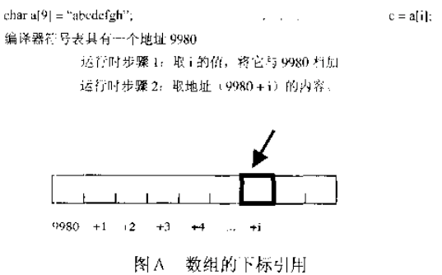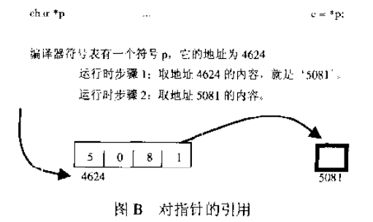

##### 定义为指针但是以数组方式引用:

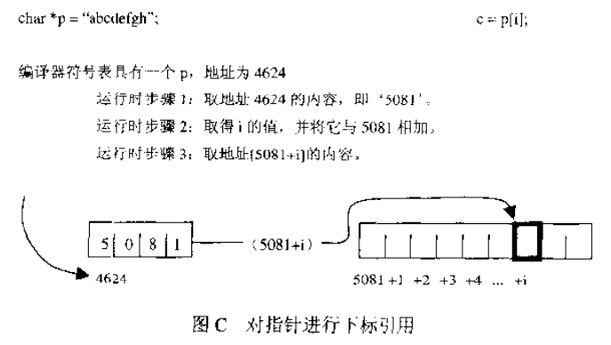

编译器将会;

1. 取得符号表中p的地址，提取存储于此处的指针。

2. 把F标所表示的偏移量与指针的值相加，产生 •个地址。

3. 访问上面这个地址，取得字符。

编译器己被告知p是个指向字符的指针(相反，数组定义告诉编详器p是一个字符序列 )。 p[i] 表示“从p所指的地址开始 ，前进i步，每步都是一个学符 (即每个元素的长度为个字节)”。如果是其他:类型的指针(如int 或double等)，其步长(每步的字节数)也各不相同.

(类型决定每个地址处的存储空间大小,由于数组元素是连续存储的,因此不同类型的数组的地址步长不同,等于类型的字节数大小)。

##### 定义为数组,但是以指针形式声明使用是不合法的:

extern char *p;

char p[10];

因为数组名本身就代表其地址,如果声明为指针,那么使用的时候就会先取数组名对应的地址中的内容,即为一个ascii字符,再将其作为一个地址取其内容,这样显然是不合理的.

指针相比于数组名的灵活性在于:

指针本身始终位于同一个地址,但是它的内容在任何时候都可以不同,指向不同地址的int变量,这些不同的变量可以右不同的值.

指针指向的是匿名数据,只能用指针进行间接操作.

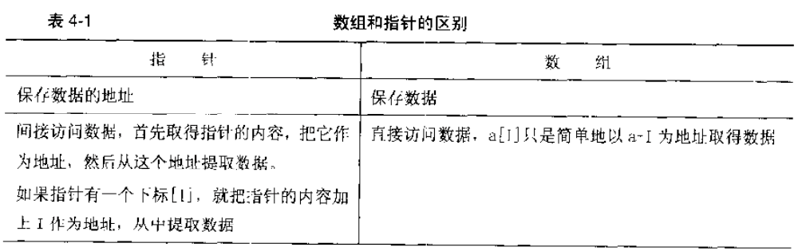

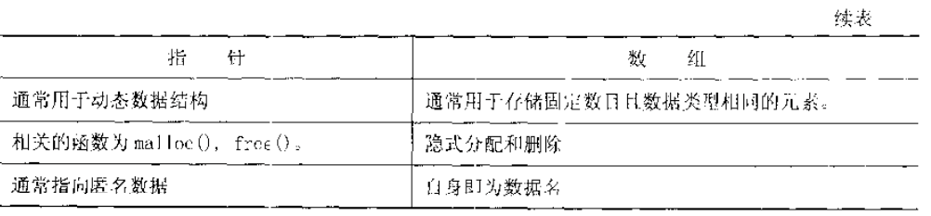

## 链接

编译器是右多个单独程序加编译器驱动器组成的.

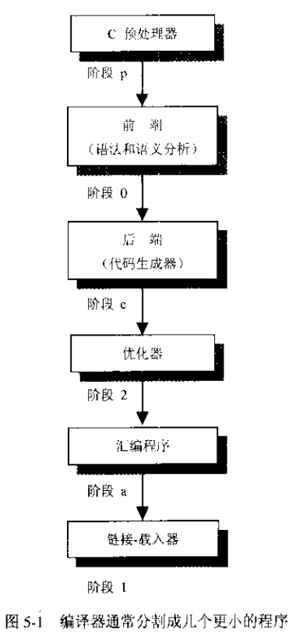

使用-v选项查看编译过程中的独立阶段:

➜  c gcc -E cdecl.c -o cdecl.i //预处理

➜  c gcc -S cdecl.i -o cdecl.s //编译

➜  c gcc -c cdecl.s -o cdecl.o //汇编

➜  c gcc cdecl.o -o cdecl.out //链接

##### 链接

日标文件并不能直接执行，已音先需要载入到链接器。链接器确认main函数为初始进 入点(程序开始执行的地方)，把符号引用(symbolic reference)绑定到内存地址，把所有的目标文件集中在一起，再加上库文件，从而产生可执行文作。

##### 静态链接和动态链接

静态链接:函数库的拷贝被包含到可执行文件中

链接编辑(link-editing)->载入(loading)

动态链接:可执行文件只包含了文件名,载入器在运行时寻找程序所需的函数库

链接编辑(link-editing)->载入(loading)->运行时链接(runtime linking)

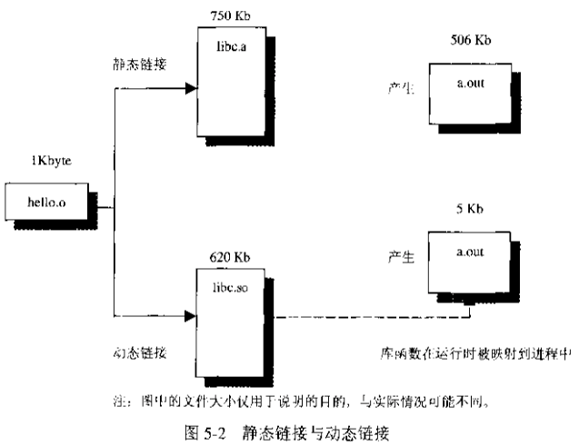

##### 动态链接的优点

1. 可执行文件体积更小,节省磁盘空间和内存,因为函数库只有在需要时才被映射到进程中;
2. 所有动态链接到某个函数库的可知行文件在运行时共享该函数库的一个单独拷贝,如果是静态链接的,那每个可执行文件都会持有一份拷贝;
3. 链接编辑阶段时间更短(但可执行文件的启动速度稍受影响)
4. 能够把程序与它们使用的特定函数库版本分离开来,只要按照约定由系统向程序提供一个稳定接口,该接口不随时间和系统版本而变化. 保证应用程序不会受到和底层系统软件升级的影响.这样函数库的升级将更加容易,而且允许用户在运行时选择需要执行的函数库.

这种介于应用程序和函数库二进制可执行文件所提供的服务之间的接口,被称为应用程序二进制接口(Application Binary Interface, ABI).

##### 使用动态链接库

函数库路径:

使用动态链接(just-in-time, JIT)的应用程序在运行时必须能够找到它需要的函数库.连接器通过把库文件名或者路径名植入可执行文件中来做到这一点.所以函数库的路径不能随意移动.

当把可执行文件拿到不同机器上运行时,也需要该机器指定目录上必须存在对应的函数库,对于标准函数库来说这不成问题,因为unix标准要求动态链接必须保证4个特定的函数 库:libc(C运行时函数库)、libsys (其他系统函数)、libX(Xwindowing)和libnsl (网络服务)。

创建动态或者静态链接库:(后缀,静态库.a (archive), 动态库.so (shared object))

编译一些不包含main函数的代码,并将生成的.o文件用工具进行处理(ar, ld,编译器链接工具)

###### 用gcc创建库文件:

先编译得到目标文件:

gcc -c cdecl.c

然后:

gcc -shared -o libcdecl.so cdecl.o

gcc -static -o libcdecl.a cdecl.o

###### 链接现有的库文件:

gcc -L/path/to/library/during/link -R/path/to/library/during/runtime -l<libname withou ‘lib’>

gcc main.c -L. -lcdecl

###### 调查链接错误:

nm命令能够显示库文件中的所有符号

nm <library> | grep -v UNDEF

排除不在该库文件中定义的symbol

###### 静态链接的另一个问题

静态链接时,各个静态库出现的顺序很重要,链接器时按照从左到右的顺序进行解析的,

gcc -lm main.cc

因为引入math库(如果是静态库)时,还没有出现未定义的符号,所以它不会从math库中提取任何符号,这样连接器在处理main.c中的对math库函数的引用时会出现未定义的错误.

引用动态库不会有这个问题,因为在动态链接中,所有的库符号进入输出文件的虚拟地址空间中,所有的符号对于链接在一起的所有文件都是可见的,但是处理静态链接库时,链接器只是在其中查找载入时当时所知道的未定义符号.

## 运行时

代码和数据有何区别?可以认为它们的区别是编译时和运行时的分界线.

编译时翻译代码,运行时进行数据存储管理

###### out

assember output的缩写.

可以有不同的格式:

ELF(extensible linker format, executable and linking format)

COFF(common object-file fomrat)

###### 段

unix下的段:

一个二进制文件相关的内容块(可能包含多个节,section).

intel x86内存模型中的段:

一种组织内存地址空间的设计概念,地址空间被分成一些64k大小的区域,称之为段.

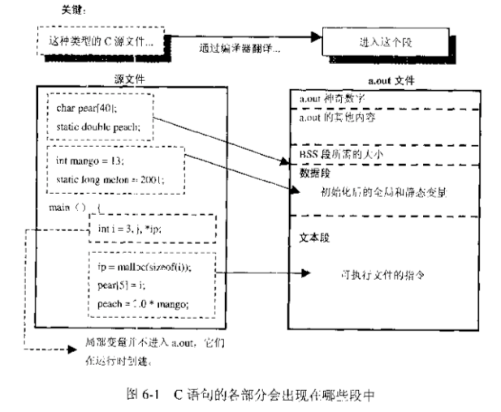

bss(block started by symbol)只保留没有值的变量,所以它实际上并不需要保存这些变量本身而只是记录了它们所需的大小.

###### 操作系统在a.out里做了什么

可执行文件的段在运行时会被载入器读入到内存中,每个区域有特定目的:

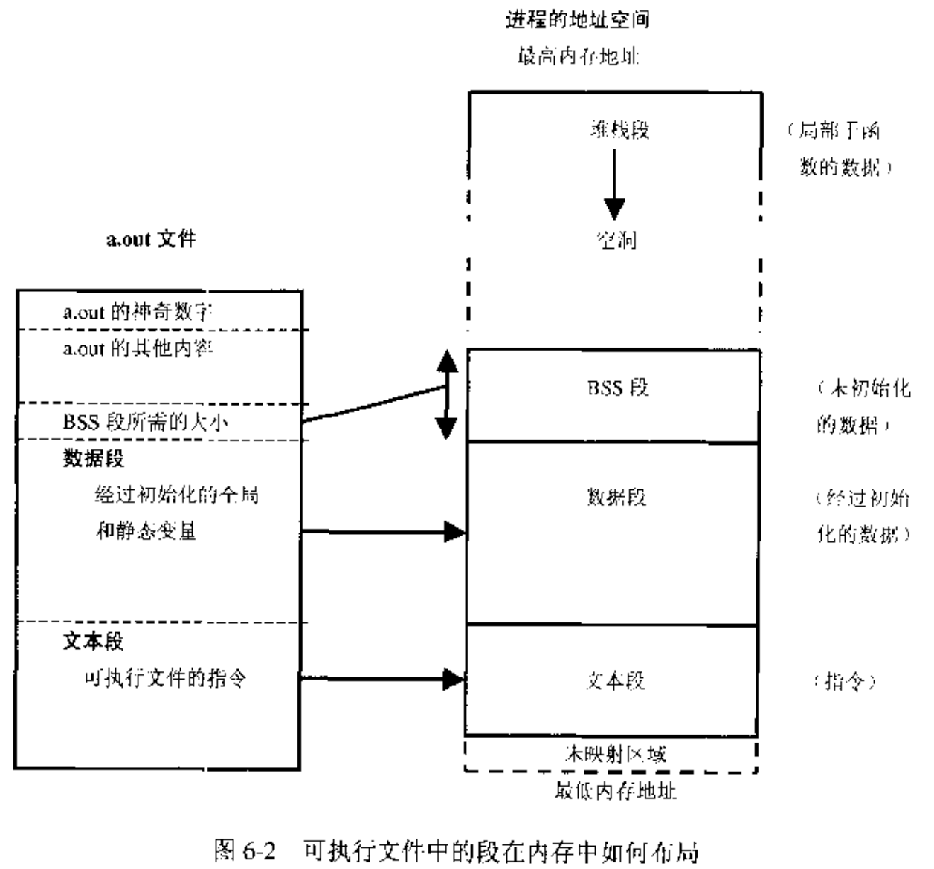

文本段包含程序指令,它直接被拷贝到内存中(一般使用mmap()系统调用).文本段的内容和大小一般不会改变,因此有些操作系统可以给段中不同section设定读写属性

如设定文本段为read-and-execute-only

设定某些数据为read-write-no-execute,另一些数据为read-only等.

数据段包含初始化的全局和静态变量和它们的值.

bss段包含未初始化的全局和静态数据,紧随数据段之后,这部分内存区域在运行时会全部清0

数据段+bss段统称为数据区,数据区就是一片连续的虚拟地址空间,一般情况下,任何进程中数据区都是最大的段.

堆栈段(stack segment)用于保存局部变量、临时数据、传递到函数中的参数等.

堆空间(heap)用于动态分配内存

虚拟地址空间的最低部分并未被映射,所以这部分位于进程的地址空间内但并为赋予物理地址,任何对它的引用都是非法的,典型情况下这部分是从地址0开始的几k字节,它用于捕捉使用空指针和小整型值的指针引用内存的情况.

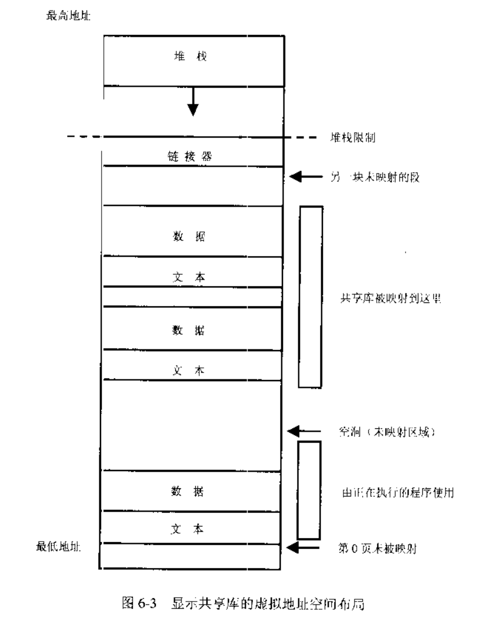

###### c语言运行时在a.out里做了什么

stack segment

- local(automatic) variables inside functions

- housekeeping info for function calls, known as stack frame or procedure activation record

- address from which function call is made, where it will return later

- parameters that won’t fit into registers

- stored register values

- temporary storage

for example:

- arithmetic expression results

- allocal() uses storage from stack

stack is needed in C because recursive function calls are allowed.

simple program to print address of different segments:

#include <stdio.h>

#include <stdlib.h>

int x = 0;

int y;

int main()

{

int a[3] = {0, 0, 0};

int i;

int j;

int d[2] = {1,1};

int *h = malloc(sizeof(int)*2);

printf("sizeof pointer %ld\n", sizeof(h));

printf("sizeof int %ld\n", sizeof(int));

printf("array a %p %p %p %p\n", &a, &a[0], &a[1], &a[2]);

printf("array d %p %p %p\n", &d, &d[0], &d[1]);

printf("stack %p %p %p %p %p %p\n", &a, a, d, &i, &j, &h);

printf("heap %p\n", &h[0]);

printf("bss %p\n", &y);

printf("data %p\n", &x);

long daddr = &x;

daddr -= sizeof(x);

printf("text %s\n", (const char*)daddr);

return 0;

}

sizeof pointer 8

sizeof int 4

array a 0x7ff7be7d156c 0x7ff7be7d156c 0x7ff7be7d1570 0x7ff7be7d1574

array d 0x7ff7be7d1564 0x7ff7be7d1564 0x7ff7be7d1568

stack 0x7ff7be7d156c 0x7ff7be7d156c 0x7ff7be7d1564 0x7ff7be7d155c 0x7ff7be7d1558 0x7ff7be7d1550

heap 0x6000003b0040

bss 0x101736004

data 0x101736000

text

###### what happens when a function gets called

stack frame (procedure activation record)

/usr/include/sys/frame.h

https://svnweb.freebsd.org/base/head/sys/x86/include/frame.h?revision=247047&view=markup

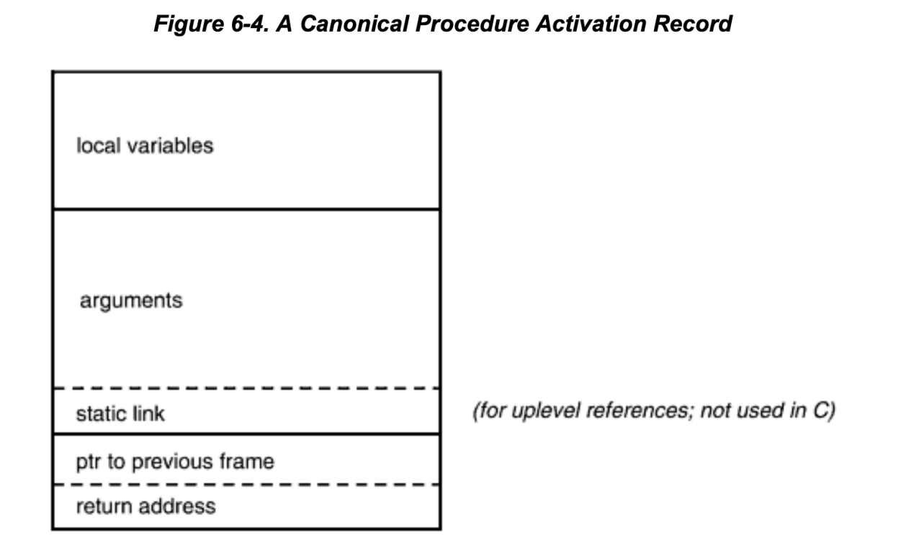

C doesn't have static link to upper enclosing procedure, with which can be used to access upper level stack frame and hence the data local to it. Thus C doesn’t support nested functions (define function inside function).

It’s called static link because it’s decided at compile time, while the frame pointer chain is dynamic linked in which the pointer is pointing to previous procedure at runtime).

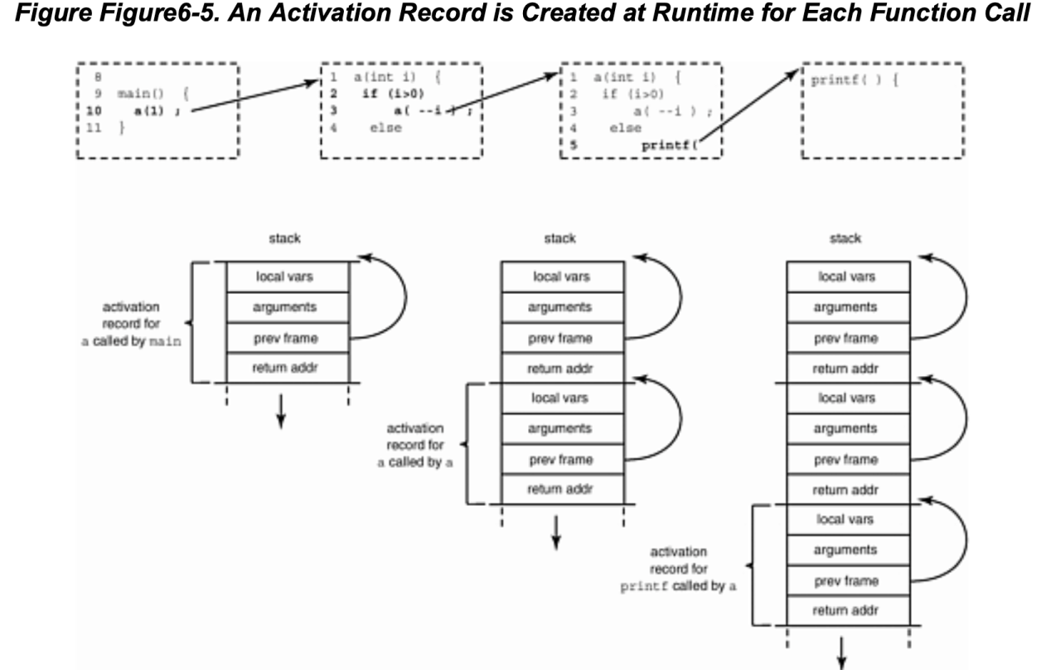

The pointer to previous frame makes it easier for popping the stack back to previous record when current function returns. (as different record would have different size).

static and auto

- Knowing that stack will be popped after the function returns, you should never return pointers to a local variable declared inside the function. Use static variables or heap memory instead.

- auto in C language means that the variable’s storage will be allocated automatically, compared to statically allocated at compile time or dynamically allocated on heap. It can only be used inside a function but variable declaration enables that attribute by default.

so actually auto is not needed for C programmers.

###### stack frames could be on registers/ heaps besides stack.

###### Threads of control

For threads, each will have a separate stack for its control of function calls.Each thread gets a stack of 1Mb (grown as needed) and a page of red zone betweeen each thread's stack.

###### setjmp and longjmp

Setjmp saves a copy of the **program counter** and the **current pointer to the top of the stack**. This saves some initial values, if you like. Then longjmp restores these values, effectively transferring control and resetting the state back to where you were when you did the save. It's termed "**unwinding the stack**," because you unroll activation records from the stack until you get to the saved one. Although it causes a branch, longjmp differs from a goto in that:

* A **goto can't jump out of the current function in C** (that's why this is a "longjmp"— you can jump a long way away, even to a function in a different file).
* You **can only longjmp back to somewhere you have already been, where you did a setjmp**, and that still has a live activation record. In this respect, setjmp is more like a "come from" statement than a "go to". Longjmp takes an additional integer argument that is passed back, and lets you figure out whether you got here from longjmp or from carrying on from the previous statement.

A setjmp/longjmp is most useful for **error recovery**. As long as you haven't returned from the function yet, if you discover a unrecoverable error, you can transfer control back to the main input loop and start again from there. Some people use setjmp/longjmp to return from a chain of umpteen functions at once. Others use them to shield potentially dangerous code, for example, when dereferencing a suspicious pointer as shown in the following example.

typedef void(*ptr_to_func)(int);

ptr_to_func signal(int, ptr_to_func);

#include <signal.h>

#include <setjmp.h>

#include <stdio.h>

jmp_buf jbuf;

void

termination_handler (int signum)

{

printf("we are going to longjmp back to switch\n");

longjmp(jbuf, 1);

}

int

main (int argc, char** argv)

{

if (signal (SIGSEGV, termination_handler) == SIG_IGN)

signal (SIGSEGV, SIG_IGN);

char *p;

//*p = 'b'; // pointers to literals are forbidden

char* ss = "hello world"; // pointers to string literals are ok

// char* suspicious = &a;

char *suspicious = 0;

char d = 'e';

volatile char f = 'g';

printf("before d = %c f = %c\n", d, f);

char c;

switch(setjmp(jbuf)) {

case 0:

d = 'f';

f = 'h';

printf("suspicious: %c\n", *suspicious);

break;

case 1:

printf("after d = %c f = %c\n", d, f);

printf("suspicious is indeed a bad pointer\n");

break;

default:

printf("unexpected value returned by setjmp\n");

}

return 0;

}

➜  c gcc setjmp.c && ./a.out

before d = e f = g

we are going to longjmp back to switch

after d = f f = h

suspicious is indeed a bad pointer

Following command checks default stack limit:

using ulimit -s <size> to reset stack limit

➜  c ulimit -a

-t: cpu time (seconds)              unlimited

-f: file size (blocks)              unlimited

-d: data seg size (kbytes)          unlimited

**-s: stack size (kbytes)             8192**

-c: core file size (blocks)         0

-v: address space (kbytes)          unlimited

-l: locked-in-memory size (kbytes)  unlimited

-u: processes                       2784

-n: file descriptors                2560

###### useful tools under linux

**nm** Prints the symbol table of an object file

**strings** Looks at the strings embedded in a binary. Useful for looking at the error messages a binary can generate, built-in file names, and (sometimes) symbol names or version and copyright information.

**sum** Prints checksum and block count for a file. An-swers questions like: "Are two executables the same version?" "Did the transmission go OK?"

**file** Tells you what a file contains (e.g., executable, data, ASCII, shell script, archive, etc.).

**time** Displays the total real and CPU time used by a program.

## Memory

###### Intel x86 memory models

A segment in the Intel x86 memory model is the result of a design in which (for compatibility reasons)

**the address space is not uniform, but is divided into 64-Kbyte ranges known as segments**.

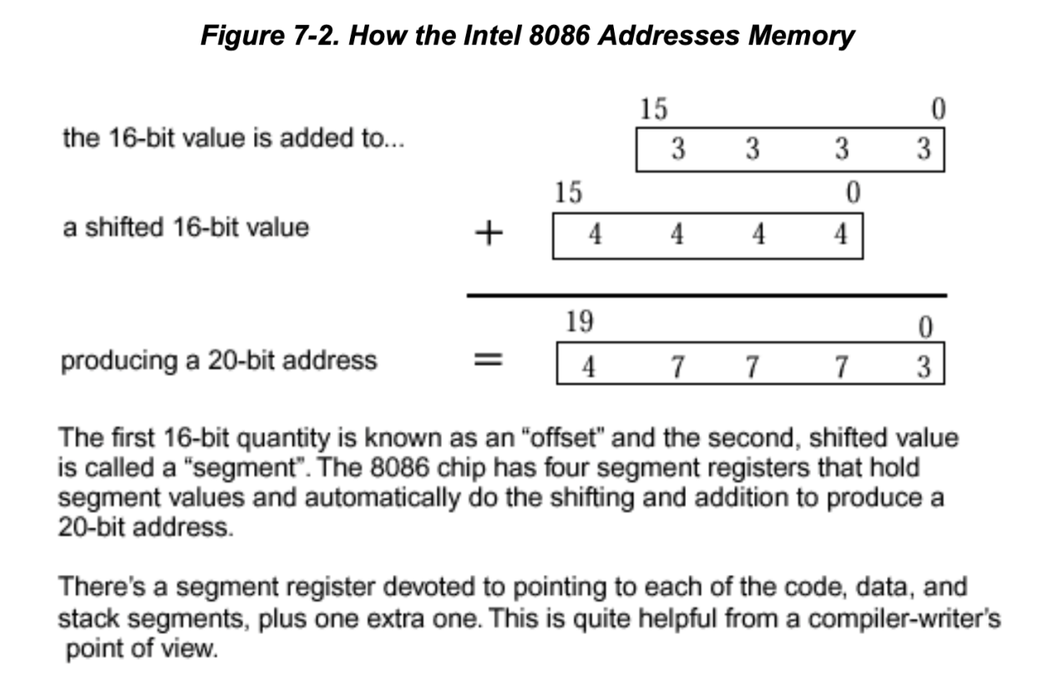

8086 has 16bits on the data bus and 20bits on the address bus.

the 20 bits is not a usual design decision, main thought is to keep backward compatibility for 8085-ported code. All subsequent 80x86 processors had to follow it or give up compatibility.

For 8085 programs, the segment registers are loaded with fixed values and then ignored, the 16bits address for 8085 will be used directly;

For 8086 programs, the segment registers are used to **firstly point to on the 8086 a 64-Kbyte region of memory**, An address is formed by taking the value in a segment register and shifting it left four places (or equivalently, multiplying by 16). Yet a third way of looking at this is to consider that the segment register value has been made a 20-bit quantity by appending four zeros.

**Then** the **16-bit offset says where the address is in that segment**. If you add the contents of the segment register to the offset, you will obtain the final address.

###### virtual memory

If it's there and you can see it—it's real  
If it's not there and you can see it—it's **virtual**  
If it's there and you can't see it—it's **transparent**  
If it's not there and you can't see it—you erased it! —IBM poster explaining virtual memory, circa 1978

Virtual memory is organized into "**pages**." A page is the unit that the OS moves around and protects, typically a few Kbytes in size. When a memory image travels between disk and physical memory we say it is being **paged in (if going to memory**) or **paged out (going to disk)**.

**paged out** - When process is not actually running(sleeping) or with a low priority, the physical memory resources allocated to it can be taken away and backed up on the disk, it is called to be “**swapped out**”. There is a special "**swap area**" on disk that holds memory that has been paged or swapped. The swap area will usually be several times bigger than the physical memory on the machine.

**paged in** - A process can only operate on pages that are in memory. When it makes are reference to a page not in memory, MMU(Memory Management Unit) generate a **page fault.** Kernel will respond and check if the reference was valid or not. If invalid it signals “segmentation violation” to the process. If valid the kernel retrieves the page from disk and the process can continue to run.

Operating systems(SunOS) has a unified view of disk systems and main memory. It uses identical underlying data structure (**vnode**, ‘virtual node’) to manipulate each. The **virtual memory operations are** organized around the single philosophy of **mapping a file region to a memory region**. This is also called “hat layer” - hardware address translation layer.

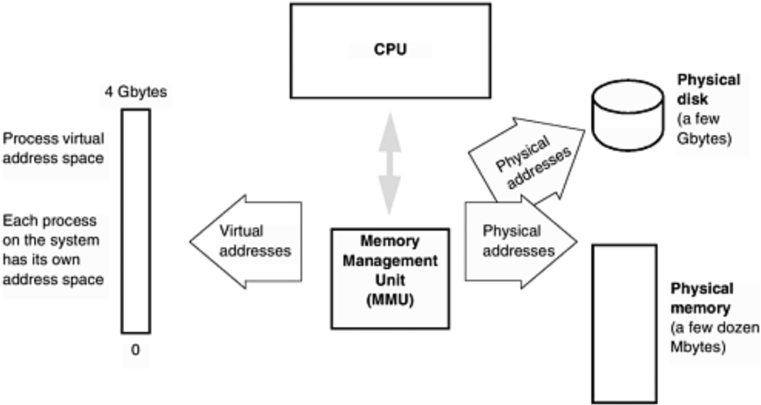

###### cache

-where is cache located

-CPU side of the MMU, **caches virtual address**, must be flushed on each context switch(as the address is relative not absolute)

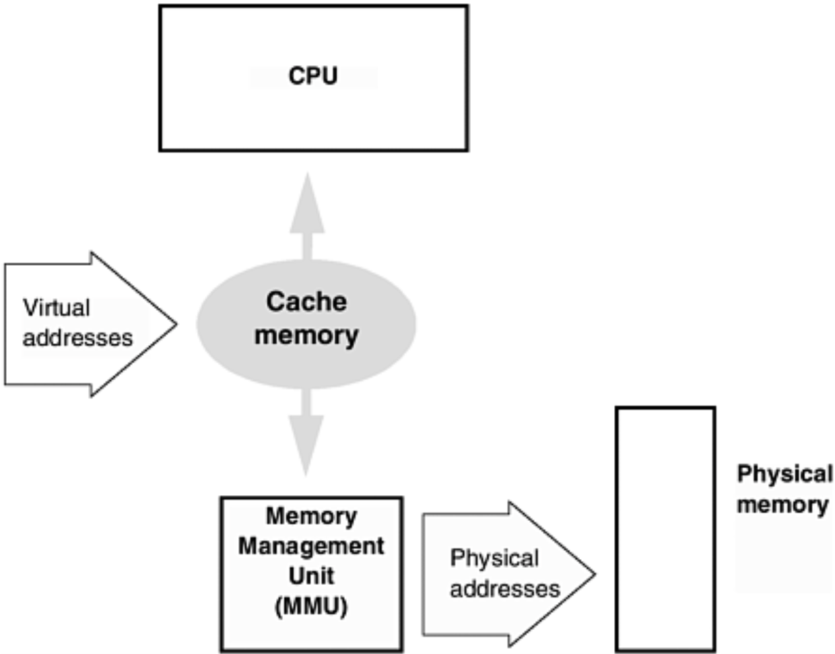

-physical memory side of the MMU, **caches physical address**

- why cache

-faster than main memory

-but also more expensive and consumes more space and power than regular memory

- how is it cached

-contains list of addresses and their contents

- read operation(request data from a particular address): read from cache first, hand over data back if it’s already in cache, otherwise access from main memory and put it into cache

- write operation(write data to a particular address): two types of write cache method, both will not block the instruction stream which will continue as soon as the cache access completes.

-**Write-through** cache— This always initiates a write to main memory at the same time it writes to the cache.

-**Write-back** cache— In the first instance, this writes only to cache. The data is transferred to main memory when the cache line is about to be written again and a save hasn't taken place yet. It will also be transferred on a context switch to a different process or the kernel.

cache is widely used

caches also can be applied **whenever there is an interface between fast and slow devices** (e.g., between disk and memory). PC's often use a main memory cache to help a slow disk. They call this "RAMdisk". In UNIX, disk inodes are cached in memory. This is why the filesystem can be corrupted by power-ing the machine off without first flushing the cache to disk with the "sync" command.

cache internal format

Line: block(data content, typical size is 32 bytes), tag(address it represents)

Line

Line

Moving of cache-block-sized chunks of data is more efficient.

an cache missing example

###### The data segment and heap

malloc -get memory from heap and return pointer pointed to memory on heap

-**everything on heap is anonymous**, you can’t access it directly by name, only indirectly through a pointer

free -give memory back to heap

alloc -like malloc but clears memory allocated to zero

realloc -changes size of a block of memory pointed to

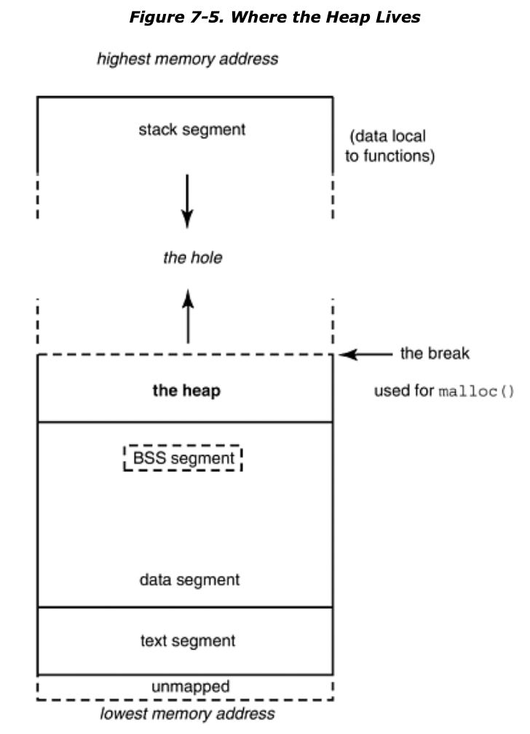

malloc and free— get memory from heap and give it back to heap

- Malloced memory is always aligned appropriately for the largest size of atomic access on a machine, and a malloc request may be rounded up in size to some convenient power of two. **Freed memory goes back into the heap for reuse, but there is no (convenient) way to remove it from your process and give it back to the operating system**.

- Heap memory doesn’t need to be returned in the same order in which is was acquired(it doesn’t have to be returned at all), the unordered malloc/free calls will eventually cause **heap fragmentation**. To manage heap memory some kind of linked list of available blocks are used and each block handed to malloc is preceded by a size count(how big is the blocks in this list) that goes with it.

brk/sbrk

- system calls that **adjust the size of the data segment to an absolute value/by an increment**, will be called by malloc underneath when process requires more memory than what current heap already has. When called the break pointer(end of the heap) will be pushed further and data segment will grow upwards(to higher address).

-Don't call brk/sbrk by yourself, it may accidentally return data segment memory to the kernel

-If you want to obtain memory that can later be returned to the kernel, use the **mmap** system call to map the /dev/zero file. To return this memory, use **munmap**.

###### Memory leaks

As described in previous section, the heap grows when malloc is called for more memory. If free is not called for each malloc, the process will lose the reference it has (the returned pointer) for that part of memory on heap and as a result it will not be free-able or reusable any more for that process. This inefficiency of memory usage for this process.

Most majority of OS will clean up process memory (including heap) when process exits, but there’re exceptions.

alloca() : allocates memory on stack - not portable

###### 总线错误

bus error(core dumped) 总线错误(信息已转储)

segmentation fault (core dumped) 段错误(信息已转储)

错误就是**操作系统所检测到的异常**，而这个异常是尽可能地以操作系统方更的原则来报告的。总线错误和段错误的准确原因在不同的操作系统版本上各不相同。

当硬件告诉操作系统一个**有问题的内存引用时，就会出现这两种错误**。操作系统通过问 出错的进程发送一个信号与之交流。信号就是一种事件通知或一个软件中断，在UNIX系统 编程中使用很广，但在应用程序编程中几乎不使用。在缺省情况下，进程在收到“总线错误” 或“段错误” 信号后将进行**信息转储**并终止。不过可以为这些信号设置—一个信号处理程序 (signal handler)，用于修改进程的缺省反应。

-总线错误

由于**未对齐的内存读写导致**.对齐(alignment)的意思就是数据项只能存储在地址是数据项大小的整数倍的内存位置上.

在现代的计算机架构中，尤其是RISC 架构，都需要数据对齐，因为与任意的对齐有关的额外逻辑会使整个内存系统更大且更慢。通过迫使每个内存访问局限在一个Cache 行或一个单独的页面内，可以极大地简化 (并加速)如Cache控制器和内存管理单元这样的硬件。

例 如 ，访 问 一 个 8 字 节 的 d o u b l e 数 据 时 ，地 址 只 允 许 是 8 的 整 数 倍 。所 以 一个 d o u bl e 数据可以存储于地址:24、8008或32768，但不能存储于地址1006 (因为它无法被8整除)。

-段错误

segmentation violation一般由于引用一个未初始化或非法值的指针引起的。有各种原因可能导致指针的值为非法的，所以段错误一般不能提示引起错误的原因，而且如果指针的值恰好是未对齐的值，那么它会产生总线错误而不是段错误（CPU向MMU发送地址之前会先检察它是否对齐）。

几种常见导致segv的原因：

1. 解引用值非法的指针；
2. 解引用空指针；
3. 未取得权限时进行访问；
4. 栈或者堆空间被用完了

## 原型

###### ANSI C标准中的类型提升

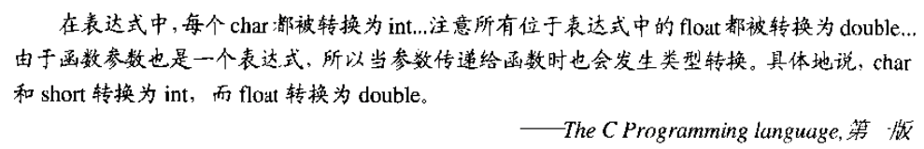

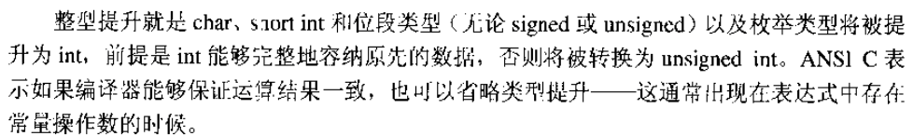

除了寻常算术转换之外，表达式中会发生上述类型提升。

**编译器可以在保证结果不发生溢出的情况下省略类型提升**：

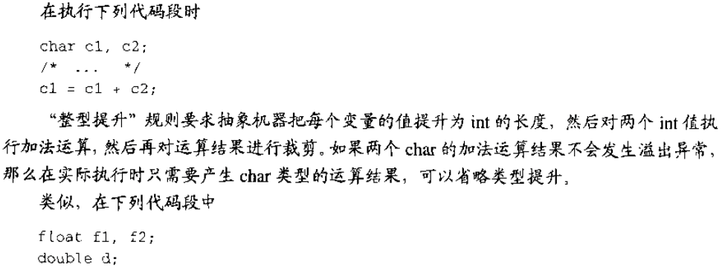

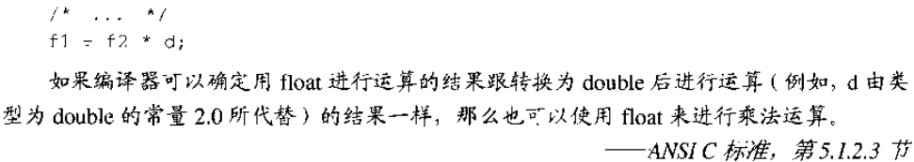

类型提升是简化编译器的一种想法，通过把所有的操作数转换为统一的长度简化了代码的生成，这样，压到堆栈中的参数都是同一长度的，运行时系统只需要知道参数的数目而不需要知道它们的长度。